James P. Kelly
2012 Latin Grammy Nominee Member, The Recording Academy GRAMMY® Voter jpk@jpkellymusic.com 310.663.3152

To Whom It May Concern:

I am writing to you today to recommend, in the highest possible terms, Brandon Zuniga. I have come to know Brandon in my capacity as a professor of music production at Manhattan College in Riverdale, New York. There, Brandon thrives as a student of music technology, theory, and
performance. His academic pursuits have included a wide array of audio and music-related coursework, and his DAW-related skills include Pro Tools and Logic Pro. In addition, he possesses the foundational knowledge of audio editing, mic technique, signal flow, and live sound needed to progress in any music or audio environment.

As a Latin-Grammy-nominated engineer and producer myself, I know what it takes to excel in a support role—be it in a studio or as an assistant to an industry professional. Brandon possesses those qualities: he is driven and works himself to bone to accomplish the tasks set out before
him. His academic record and history of employment are a testament to his work ethic and trustworthiness.

As a person, Brandon is kind, calm, and an extremely quick learner. He is comfortable operating in any genre, and possesses a producer/engineer's ear. An opportunity in the music and audio industry will allow him to further his life’s goal: to work as a sound engineer and producer.

Please do not hesitate to contact me at the email address or phone number above if you would like to discuss Brandon’s candidacy further.

Until, I remain sincerely yours,
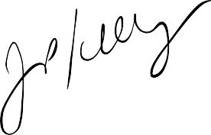
James Patrick Kelly

